IE User Manual of Network Camera

|  |  |  |  |
| --- | --- | --- | --- |
| Version Explain | | | |
| Version | Description | Date | Author |
| V1.01 |  | 2013/9/5 | Beyond |
| V1.02 |  | 2015/11/20 | Dehone |
| V1.03 |  | 2017/3/17 | Dehone |
| V1.04 |  | 2020/10/15 | Weizhi |
| V1.05 |  | 2021/5/12 | Beyond |

# Preface

## Overview

## This document describes the main functions and usage methods of Internet Explorer Web interface for universal network camera (IPC) of Shenzhen Icamvision Technology Co., LTD. This paper introduces network access, parameter configuration, protocol setting, storage management, device reset, permission management, and troubleshooting, so that users can quickly master the web page function of the device.

Audience

* This document is intended for:
* Technical Support engineer
* Maintenance engineer
* Network camera operator

Symbolic convention

The following symbols may appear in this article. They represent the following:

|  |  |
| --- | --- |
| Symbol | Explain |
| Danger | Indicates an imminently hazardous situation which, if not avoided, will result in death or serious injury. |
| **Warning** | Indicates a potentially hazardous situation which, if not avoided, could result in death or serious injury. |
| Be careful | Indicates a potentially hazardous situation which, if not avoided, could result in minor or moderate injury. |
| Attention | Indicates a potentially hazardous situation which, if not avoided, could result in equipment damage, data loss, performance deterioration, or unanticipated results. Caution does not involve personal injury. |
| 🕮 Explain | Highlights important information, best practices, and tips.  Note is used to address information not related to personal injury, equipment damage, and environment damage |

Danger：

* Keep the power plug clean and dry to avoid electric shock or other hazards

Warning：

Keep the power plug clean and dry to avoid electric shock or other hazards

1. Please use meet SELV (low voltage) safety requirements of Power supply, and according to the IEC60950-1 in line with the Limited Power Source (Limited Power Source) rated voltage is dc 12 v or 24 v ac Power supply (according to the specific model and decide).

2.If equipment is not normal work, please contact to buy equipment stores or nearest service center, do not remove or modify the equipment in any way (the problems caused by unauthorized modifications or repair, your responsibility).

3. To reduce fire or shock hazard, do not let this product is the rain, or be affected with damp be affected with damp.

4.This installation should be conducted by professional service personnel, and in accordance with local regulations.

Please use the product standard of the attachment. The power supply voltage of the device must meet the input voltage requirements.

5.Equipment installed in voltage instability regions, need to grounding device, release the surge of high-energy, prevent power equipment burn out.

6.When using the equipment, please don't let water or any liquid flow into the equipment. If liquid flows into the device unexpectedly, disconnect the power supply immediately and remove all cables (such as power cables and network cables) from the device.

7. Equipment installed in the lightning prone areas, need to be grounded to the nearest, release lightning on high-energy, prevent equipment damage.

8.Wiring should be installed in buildings in the group of power equipment into the easy to use. Instructions for mounting equipment to ceiling: After installation, ensure that the connection can withstand a downward pull of at least 50 Newton (N).

Attention：

Before camera running, please check whether the power supply is correct.

Unless otherwise indicated in the user documentation, please don't use camera at temperature below 20 ℃ (4 f) and more than + 70 ℃ (140 ℉) + environment. If the device is used beyond the temperature range, the image display of the camera may be abnormal, and the device may be damaged for a long time.

This product belongs to the static sensitive equipment, improper electrostatic potential for video camera is damaged, when removing and installing equipment electrostatic protective measures and to ensure reliable grounding.

Please do not use equipment fell on the ground or strong knock, and the device away from the location of the magnetic field interference, avoid installation to the surface vibration or vulnerable places.

Do not directly touch to the image sensor optical element, clean if necessary, please use clean cloth with alcohol slightly moist, gently wipe the dirt away; Add a dust cover to protect the image sensor when the camera is not in use.

Please don't place the machine in damp, dusty, extreme heat, cold, strong electromagnetic radiation and so on.

Equipment installed in the outside, please be sure to far away from insects and moisture to avoid PCB corrosion and impact monitoring.

Please pull plug on our equipment if you don’t need use in long time.

When unpacking, please confirm whether the fragile label damage, if there are any damage, please contact customer service or sales staff.

Special statement

The products sold by our company are all delivered after our strict inspection and testing. The products are accompanied by nameplates, instruction manuals and accessories. Our company will not be responsible for all the products not produced by our company or fake products produced by our company.

This manual may contain technical inaccuracies, inconsistencies with the function and operation of the product, or typographical errors. Our company will update this manual according to the enhancement or change of product functions, and will periodically improve and update the software and hardware products described in this manual. The updated content will be added to the new version of this manual without prior notice.

The content in this manual is for reference only and is not guaranteed to be identical with the actual object. The actual object prevails.

## Contents

Network Camera 1

IE User Manual 1

V1.05 1

Preface 2

Description 2

Reader 2

Symbol 2

Special Announcement 3

Contents 4

一、Product Description 6

1.1 Operating Environment 6

1.1.1 PC Hardware Basic Request 6

1.2.2 Operating System Configuration Request 6

1.2.3 IE Browser Version Request 6

1.2.4 Local Network Configuration 7

二、Webpage Login 8

2.1 Login Interface 8

三、Real Time 9

3.1 Real Time 9

四、Configuration 10

4.1 Basic Configuration 10

4.1.1Wired Network 10

4.1.2 Wifi Configuration 12

4.1.3 Time&Date 13

4.1.4 RTMP Setup 14

4.1.5 UDP 15

4.1.6 PTZ Setup 17

4.1.7 RS232 Setup 19

4.1.8 RS485 Setup 20

4.1.9 FTP Setup 21

4.1.10 Message Send 23

4.1.11 GB28181 Platform 24

4.1.12 Cloud Service 27

4.2 Audio & Video Parameter 28

4.2.1 Video Coding 28

4.2.2 Audio Image 30

4.2.3 Audio Coding 33

4.2.4 OSD Coding 34

4.3 Alarm Setup 36

4.4 Storage Management 38

4.4.1 Storage Device 38

4.4.2 Recording Setup 39

4.4.3 Scan Recording Setup 40

4.4.4 Recording File 41

4.5 System Configuration 42

4.5.1 User Management 42

4.5.2 System Maintenance 43

4.5.3 About device 44

五、FAQ 45

5.1 Can't enter Web 45

5.2 ActiveX Install Abnormal 46

Abbreviation 46

**G** 47

**U** 47

# 一、Product description

# 1.1 Operating Environment

### 1.1.1 Basic Hardware Requirements on the PC

CPU: Intel I3 or later.

Memory: 1 GB or above.

### 1.2.2 OS Configuration Requirements

Windows 7、Windows 8、Windows10。

### 1.2.3 Version Requirements for Internet Explorer

Internet Explorer 8、Internet Explorer 9、Internet Explorer 10、Internet Explorer 11。

Chrome、Firefox、Edge、Safari。

🕮 Explain

The ActiveX control needs to be installed when the Internet Explorer kernel browser accesses the web page for the first time. Users preview videos. Non-ie kernel browsers do not need to install the ActiveX. 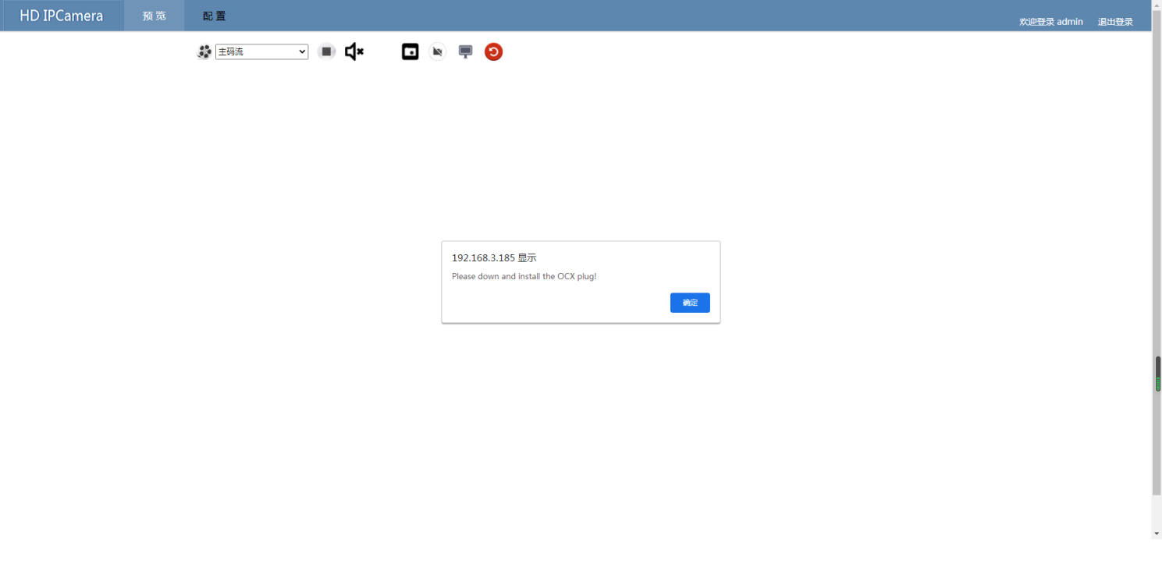

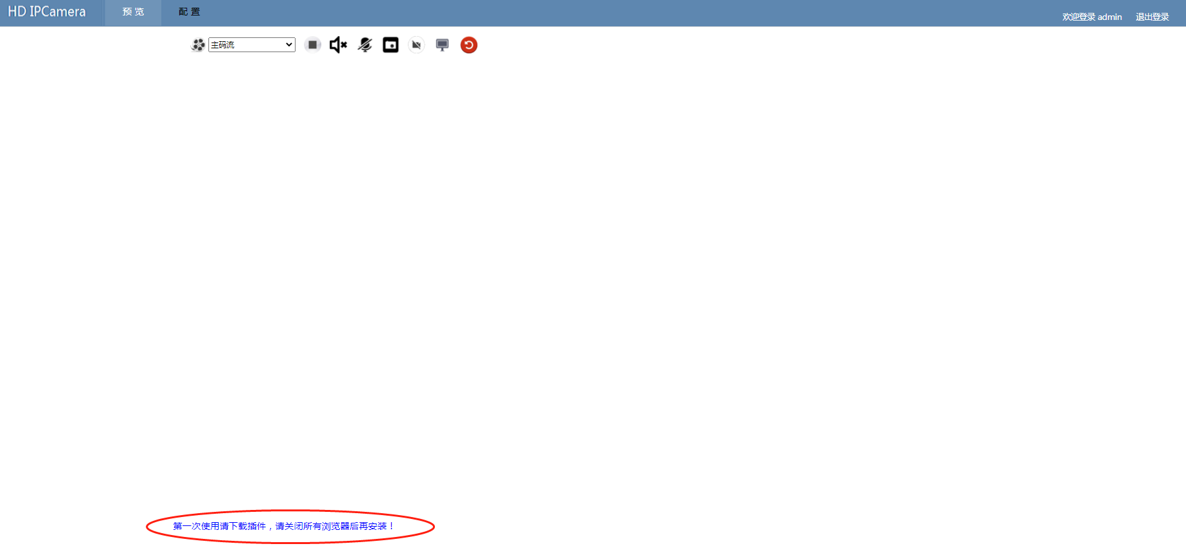

1.2.4 Local network configuration

Ensure that the IP addresses of the local PC and the device are in the same network segment. Otherwise, the login fails. Go to the Local network connection Settings and add an IP address that is in the same network segment as the device IP address to the PC network.

For example, the device IP address is 192.168.1.188. The network mask is 255.255.255.0. Gateway: 192.168.1.1

Add IP address in the same network segment as 192.168.1.X (0<X<255), subnet mask: 255.255.255.0, and gateway: 192.168.1.1 for the local PC

Attention

When adding an IP address to the PC, you can ping the IP address first to avoid IP conflict caused by other devices occupying the IP address on the LAN where the PC resides.

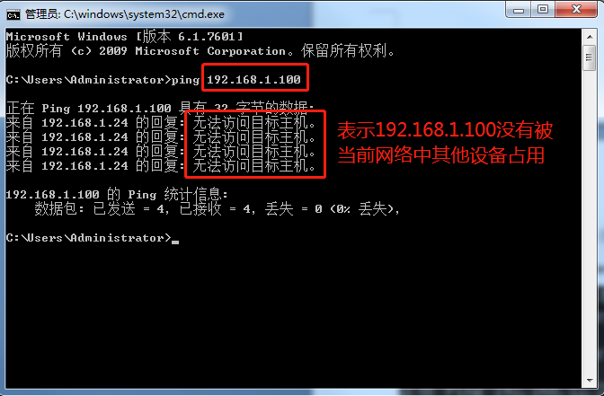

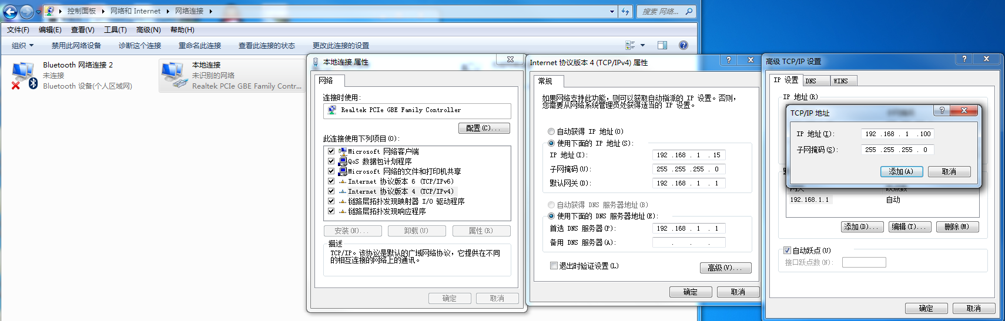

# 二、Webpage login

## 2.1 Log Interface

The default IP address is 192.168.1.188. If the IP address is changed and forgotten, use the company's IPC Search tool to search for the IP address.

* Device default webpage login account/password：**admin/admin**。
* When use IE browser to login device, please install VacamOcxSetup.exe control.

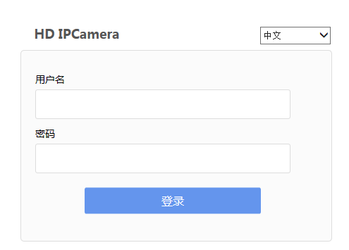

# 三、Real time

## 3.1 Real time

Web interface mainly consists of preview, exit login, primary and secondary stream selection, open/close video, open/close audio output, open/close audio input, capture, video, local storage path settings. The device that supports the PTZ can control and adjust the focal length of the device in the PTZ control 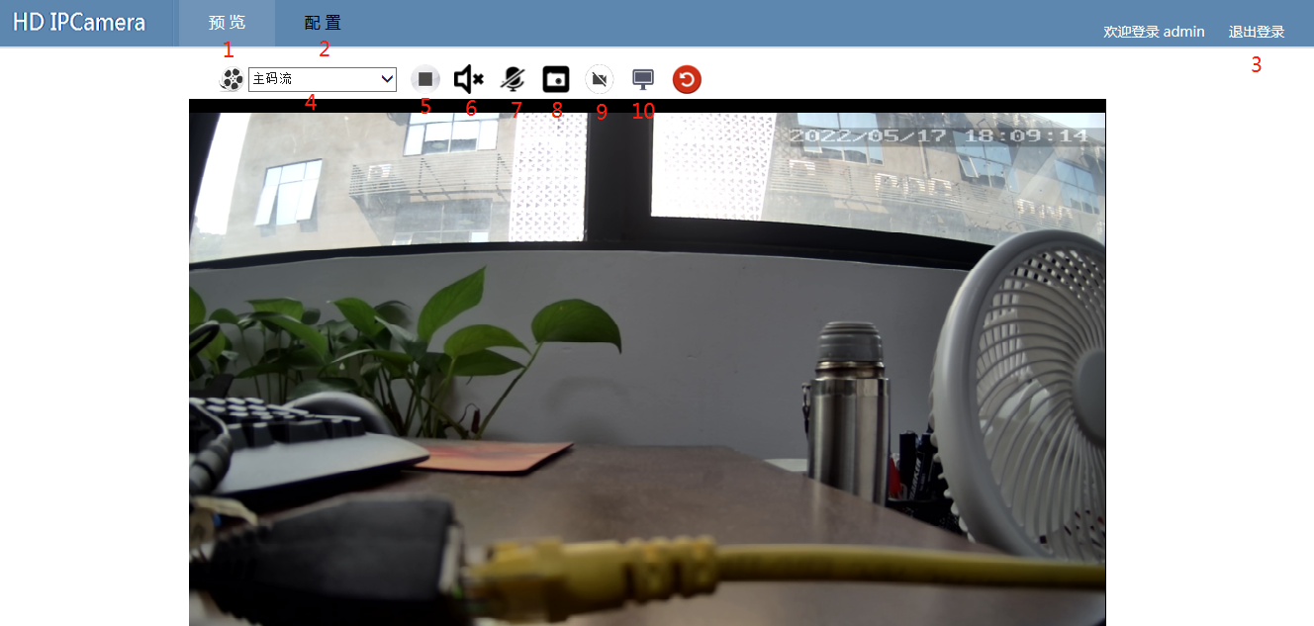

|  |  |  |
| --- | --- | --- |
| No | Function | Explain |
| 1 | Preview | Display the home page functions and real-time video. The real-time video delay is usually about 150ms |
| 2 | Configuration | Configure device parameters, including device information, video, image, network, and protocol parameters。 |
| 3 | Log Out | Log out interface and return log interface. |
| 4 | Main/Sub Stream Choice | Select whether the current preview interface is the primary or secondary bitstream, and the first and second video of the primary/secondary bitstream (the second bitstream is available only for dual-channel devices). |
| 5 | Open/Close Preview | Click to open/close the current preview screen |
| 6 | Monitoring | The audio collected by the device can be played on the client (webpage). Click the button to control the opening and closing of the monitoring function; This function can only be used if the device has an audio interface and audio input, or it has a pickup. You can preview and hear the audio on the device through IE control or terminal program (using VLC player)。 |
| 7 | Talkback | The device can play the audio collected on the client (web page). For example, the microphone port on the PC has audio input and the network camera has a speaker. Click this button to play the microphone input on the PC to the device. |
| 8 | Capture | Capture a frame of a video and save it to a path on the local PC. You can open and view the saved picture in the path on the PC. |
| 9 | Recording | Click this button to record the video in real time. Click again to end the recording and save the video to the corresponding path on the local PC. You can open and view the saved video in the save path on the PC. |
| 10 | Snapshot & Recording Storage Path | Click to open the local capture picture and video storage path on the PC. The default path is C:\IPC_WEB |

# 四、Configuration

## 4.1 Basic Configuration

### 4.1.1 Wired Network

#### Operating Instruction

Local wired network configuration include：

* Device is DHCP IP（gain IP address automatically）、static state IP
* IP address setup
* Subnet mask
* Default gateway setup
* DNS setup

#### Operation step

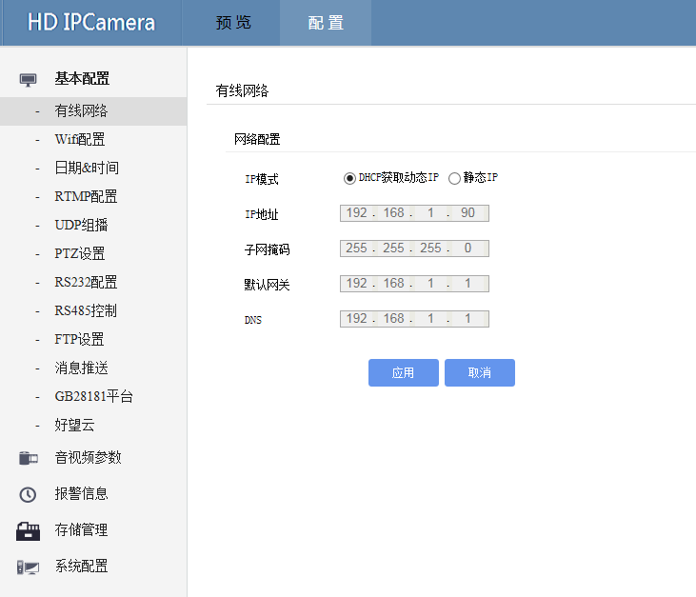

|  |  |  |
| --- | --- | --- |
| Parameter Setup | How to understand | How to set |
| DHCP gain IP | Routes on the network where the device resides enable the function of automatically assigning IP addresses. If the device automatically obtains IP addresses, the device IP address becomes a dynamic IP address assigned by routes. | Select "Automatically obtain IP address" and click "Apply" to take effect. |
| Static State IP | Manually set the IP address, subnet mask, and gateway of the device | Enter the IP address, subnet mask, and default Ipv4 gateway in the corresponding text box. Click Apply. |
| Default Gateway | A gateway is a bridge between a device and a router. A correct gateway configuration ensures that users can access the Internet properly. |  |
| DNS | DNS affects the connection rate between the device and the Internet server. You can use the device gateway as DNS or use 8.8.8.8. | Enter the corresponding value in the corresponding input box and click "Apply" to take effect。 |

Attention

### Note: When setting IPv4, ensure that the configured IP address is consistent with the default gateway.

### 4.1.2Wifi configuration

#### Operation instructions

Wifi configuration allows you to select and operate Wifi related options, including

* Work pattern：WLAN、AP hotspot
* SSID
* Search SSID and choose
* SSID password

#### Operation steps

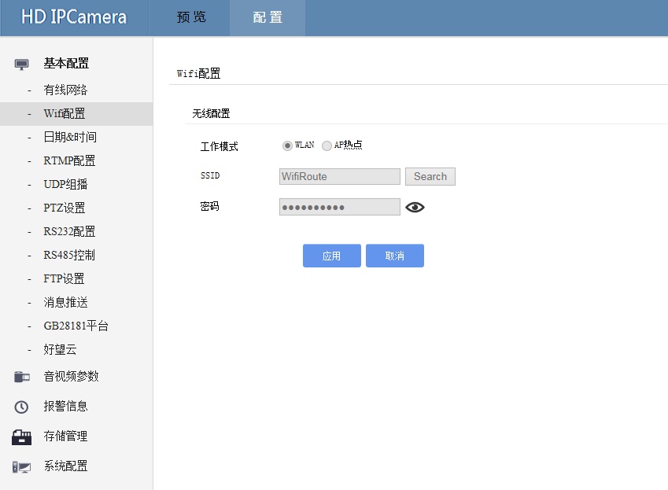

|  |  |  |
| --- | --- | --- |
| Parameter Name | How to understand | How to set |
| WLAN | Set the device as a network camera connected to a WIFI router on the LAN | Click "Apply" to take effect. |
| AP hotspot | Set the device to WIFI hotspot mode. Client devices such as a PC or mobile phone can connect to the network camera directly | Click "Apply" to take effect. |
| SSID search and choice | Search for the SSID name of the WIFI router on the LAN | Click [search] and you can see the SSIDs of all nearby WIFI routers that can be searched in the list below |
| SSID password | SSID password of the selected WIFI router | Enter the password directly in the input box. The password is not displayed by default. You can click the eye on the right to change the password mode. |

### 4.1.3 Time&Date

#### Operating instructions

The Time and date screen allows you to modify the time and date of the device. The configurable items include:

* Show current time and date
* NTP server open and close
* NTP server address
* NTP server address
* Synchronization time

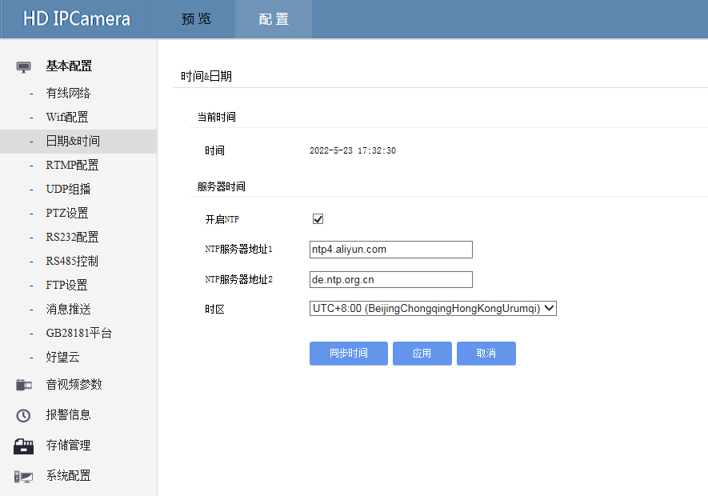

|  |  |  |
| --- | --- | --- |
| Parameter Name | How to understand | How to set |
| Device Time | Display current device time and date. | The device automatically corrects the time after networking. |
| Enable/Close NTP | Enable or disable the NTP service. After the NTP service is disabled, network time correction cannot be performed. Network Time Protocol (NTP). Device time can be synchronized through the NTP server.  Note: If NTP is on a WAN and the device needs to be able to access the Internet, check whether the IP address, subnet mask, gateway, and DNS Settings are correct | Click the check box and then click Apply to make it take effect. It is enabled by default |
| NTP Server Address 1 | Enter IP address 1 of the NTP server | Input ntp4.aliyun.com |
| NTP Server Address 2 | Enter IP address 2 of the NTP server | Input de.ntp.org.cn |
| Time Zone | Choose a time zone. There are 24 time zones in the world | Select from the drop-down list and click "Apply" to take effect. By default, "Beijing Time (GMT+8:00)" takes effect. |

### 4.1.4 RTMP Set

#### Operating instructions

Real Time Messaging Protocol (RTMP) Real-time message transmission protocol, used to push device video stream data to the target RTMP server, the client can obtain video stream from the RTMP server, can be applied in application scenarios such as live streaming.

* RTMP server number
* RTMP server open and close
* RTMP server address
* RTMP server name
* RTMP server visit password
* Choose video stream

#### Operating steps

|  |  |  |
| --- | --- | --- |
| Parameter Name | How to understand | How to set |
| RTMP server number | Select the RTMP server number to be set. Two RTMP server numbers are optional. That is, two RTMP servers can be set | Select a value from the drop-down list. Two options are available. The default value is 1 |
| Enable the RTMP function | Enable/Disable RTMP function. | Select "Enable RTMP function" and click "Apply" for it to take effect. It is disabled by default. |
| RTMP Server address | RTMP server address | Enter the complete RTMP server address in the input box and click "Apply" to take effect. |
| User Name | RTMP server user name Enter a complete user name of the RTMP server in the input box. Click Apply to take effect. | RTMP server user name Enter a complete user name of the RTMP server in the input box. Click Apply to take effect. |
| Visit Password | RTMP server visit password. | Enter the complete RTMP server access password in the input box and click "Apply" to make it take effect. |
| Code Stream 0 | Push RTMP of stream 1(primary stream) to the target server. | Select from the drop-down list and click Apply to take effect. The default code stream is [0]. |
| Code Stream 1 | Push RTMP of stream 2(substream) to the target server | Select from the drop-down list and click Apply. |

🕮Explain

### The RTMP push URL is provided by the RTMP server.

### 4.1.5 UDP Multicast

#### Operation Instruction

The User Datagram Protocol (UDP) provides a way for applications to send encapsulated IP packets without establishing a connection. It does little in particular other than give applications the ability to send packets and allow them to structure their own protocols at the desired level.

* Open multicast
* Choose video stream
* IP multicast
* Multicast port
* DUP multicast broadcast address

#### Operation Steps

#### 

|  |  |  |
| --- | --- | --- |
| Parameter Name | How to understand | How to set |
| Enable Multicast | The UDP multicast function was enabled or disabled. | If it is checked, it is on. If it is not checked, it is off. It takes effect after you click [Apply]. |
| Choose Video Stream | Select the video stream of the UDP anchor. 0 indicates the primary stream and 1 indicates the secondary stream. | Select a value from the drop-down list and click Apply |
| Multicast IP | The anchor IP address | Enter the complete anchor IP address in the input box and click Apply to take effect, default [238.0.0.1] |
| Multicast Port | Anchor Port Number | Enter the anchor port number in the input box and click Apply to take effect, default [1234] |
| UDP Multicast Playback Address | Enter the UDP multicast address | Enter the UDP multicast address in the input box and click Apply. The default is [udp://@238.238.0.1:1234]. |

### 4.1.6 PTZ set

#### Operation Instruction

PTZ is used to control the speed dome camera (supported only by the device with the ptz function). It can operate the Internet Explorer web interface to control the left and right rotation of the ptz camera. This page allows you to set the PTZ function

* Enable PTZ control
* Serial port number
* Baud Rate
* Control Protocol
* PTZ Address
* PTZ control speed
* PTZ control direction

#### Operation Steps

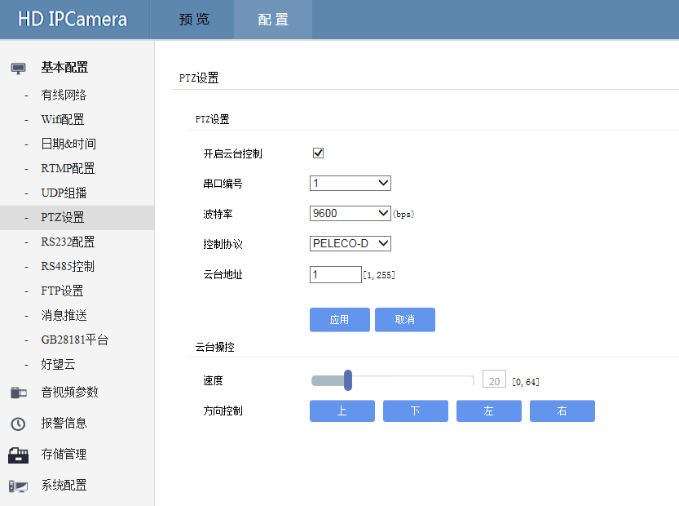

|  |  |  |
| --- | --- | --- |
| Parameter | How to understand | How to set |
| Turn on the PTZ control | Open/Close PTZ control function | If it is checked, it is on. If it is not checked, it is off. It takes effect after you click Apply |
| Serial Port Number | Select a serial port number. There are four serial port numbers. | Select from the drop-down list and click Apply to take effect. The default value is 1 |
| **[Baud rate](javascript:;)** | Select serial port baud rate, a total of 7 options: 2400, 4800, 9600, 19200, 38400, 57600, 115200. | Select a value from the drop-down list and click Apply. The default value is 9600 |
| Control Protocol | Select the RS485 control protocol. There are three options: PELECO-D, PELECO-E, and VISCA-Receive. | Select the RS485 control protocol. There are three options: PELECO-D, PELECO-E, and VISCA-Receive. |
| PTZ Address | You can enter a total of 255 cradle head device addresses from 1 to 255 | Enter the address of the cradle head in the input box and click Apply. The default address is 1 |
| PTZ Control Speed | The direction of the head and the step length of the lens focus can be adjusted. The larger the value is, the faster the head will rotate and the more sensitive the lens will focus. It is graded from 0 to 64。 | Pull the scroll bar or enter it in the input text. It takes effect after stopping. The default value is [20]. |
| PTZ Control Direction | It can control the direction of the head up and down, and control the direction of the head Hu rotation. | Click the phase direction. |

### 4.1.7 RS232 Configuration

#### Operation Instruction

You can set basic RS232 configurations to enable transparent serial port transmission.

* Open the serial port
* Serial number
* Baud rate
* Control protocol
* TCP server IP
* Server port
* Heartbeat packet interval
* RS232 test

#### 操作步骤

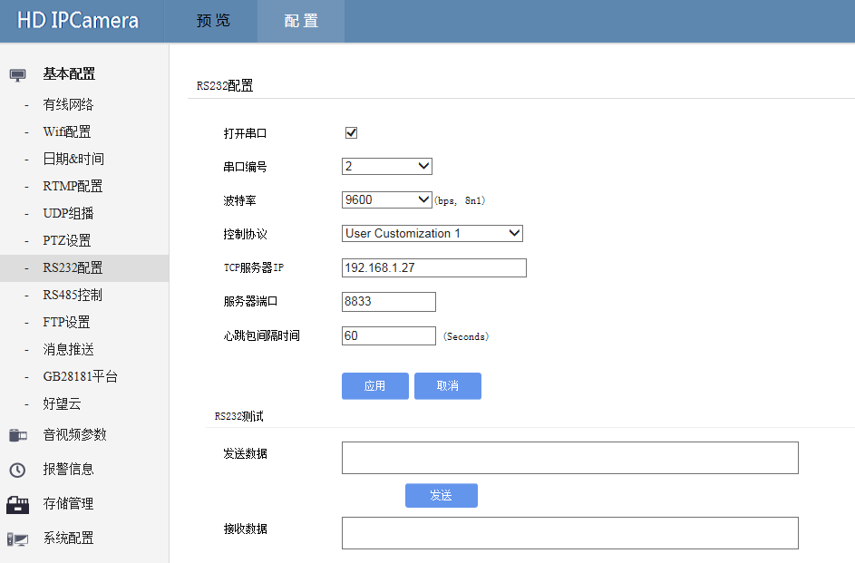

|  |  |  |
| --- | --- | --- |
| Parameter Name | How to understand | How to set |
| Open serial port | Open/Close serial port | If it is checked, it is on. If it is not checked, it is off. It takes effect after you click [Apply]。 |
| Serial port number | Choose serial port ,total: 4 pcs | Select from the drop-down list and click "Apply" to take effect. By default, "2" is selected. |
| Baud Rate | Select serial port baud rate, a total of 7 options: 2400, 4800, 9600, 19200, 38400, 57600, 115200. | Select from the drop-down list and click Apply |
| Control Protocol | RS232 control protocol：Transparent Transmission、UART to Tcp、User Customization1、User Customization2。 | Select from the drop-down list and click Apply. The default User is Customization1 |
| TCP Server Address IP | Enter the full IP address of the TCP server address | Enter the IP address in the input box and click "Apply". By default, [192.168.1.27] takes effect.。 |
| Server Port | The server port number can be entered | Enter the server port number in the input box and click "Apply" to take effect. The default is "8833". |
| Interval of heartbeat packets | You can enter the interval of heartbeat packets | Enter the heartbeat packet interval in the input box and tap Apply. The default value is 60 |
| RS232 test | You can test whether RS232 is normal by sending and receiving verification | Enter the character to be sent in the send data box and click Send. If the character can be received in the receive box, it indicates that the transparent transmission of the RS232 serial port is normal |

### 4.1.8 RS485 Control

#### Operation Instruction

You can set basic RS485 configurations for transparent serial port transmission.

* Open RS485
* Serial port number
* Baud Rate
* Device Address

#### Operation Steps

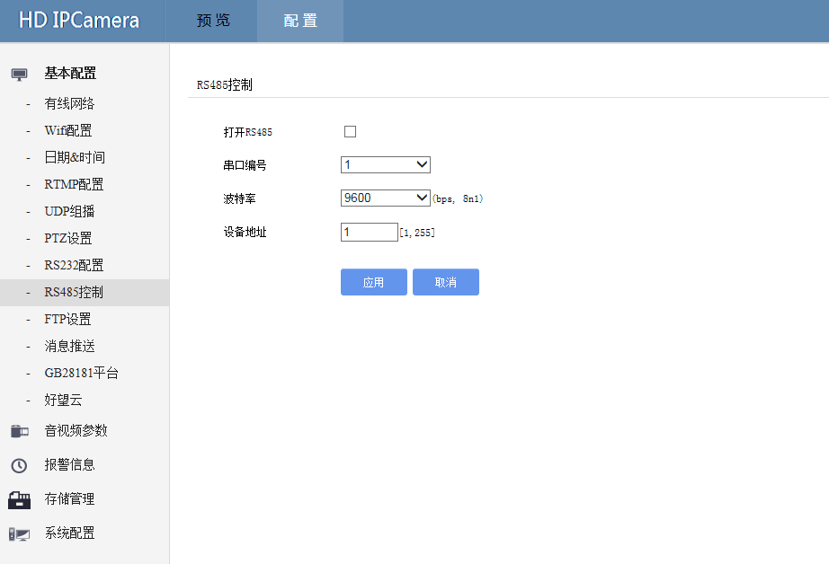

|  |  |  |
| --- | --- | --- |
| Parameter Name | How to understand | How to set |
| Open RS485 | Enable or disable the RS485 port | If it is checked, it is on. If it is not checked, it is off. Click "Apply" to take effect. |
| Serial Port Number | Select a serial port number. There are four serial port numbers | Select from the drop-down list and click "Apply" to take effect. 1 is selected by default. |
|  |  |  |
| Baud Rate | Select serial port baud rate, a total of 7 options: 2400, 4800, 9600, 19200, 38400, 57600, 115200 | Select from the drop-down list and click Apply. The default value is 9600. |
| Device Address | You can enter a total of 255 RS485 device addresses from 1 to 255 | Enter the address of the cradle head in the input box and click Apply. The default address is 1 |

### 4.1.9 FTP set

#### Operation Instruction

FTP File transfer protocol, used by the device to transfer file information to the server through linkage actions, usually used for picture and video transmission.

#### Start upload

#### To upload the file type

#### FTP server address

#### FTP server port

#### FTP server user name

#### FTP server password

####  FTP path operating steps

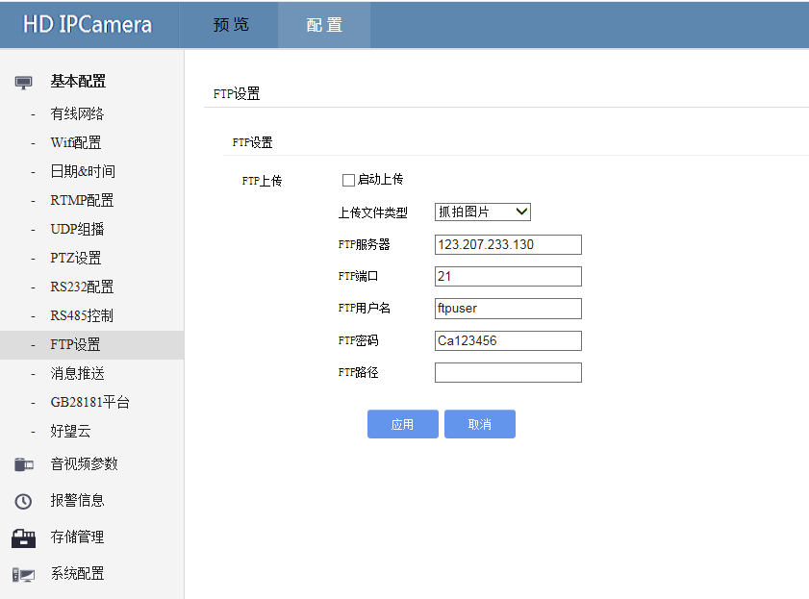

|  |  |  |
| --- | --- | --- |
| Parameter Name | How to understand | How to set |
| Start uploading | The uploading function of the FTP server was enabled or disabled. | Select "Start Upload", click "Apply" and it will take effect. By default, it is not enabled. |
| Upload file type | Select the file type that you want to upload to the FTP server. You can select five types of files: snapshot, timed video, alarm video, manual video, and all files. | Select from the drop-down list and click Apply to take effect. The default option is Capture |
| FTP server address | IP address of the FTP server. | Enter a complete FTP server IP address in the input box and click Apply to take effect. The default value is 123.207.233.130. |
| FTP server port | Port number of the FTP server | Enter the FTP server port number in the input box and click Apply. The default port number is 21 |
| FTP server name | FTP server user name | Enter the user name of the FTP server in the input box and click Apply. The default value is ftpuser. |
| FTP server password | FTP server user password | Enter the password of the FTP server in the input box and click "Apply" to take effect. The default is "Ca123456". |
| FTP path | Directory for storing data on the FTP server | Enter the corresponding value in the input box and click Apply to take effect. |

### 4.1.10 Information send

#### Operation instruction

Push the alarm message of the camera to the specified URL

Open pus

Server address

Server por

Push the request URL

User-defined

Protocol type

Heartbeat packet intervalComplete push URLOperation steps

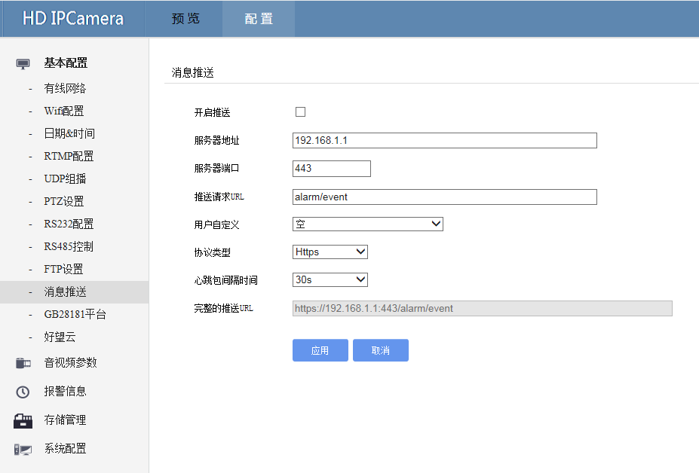

|  |  |  |
| --- | --- | --- |
| Parameter Name | How to understand | How to set |
| Enable push | Enable or disable the message push function. | Select "Enable Push", click "apply" and it will take effect. By default, it will not be enabled |
| Server Address | IP address of the server that pushes messages. | Enter the complete server IP address of the push message in the input box and click "Apply" to take effect. The default is 192.168.1.1. |
| Server Port | Port number of the server that pushes messages | Enter the server port number of the push message in the input box and click Apply to take effect. The default is [443]. |
| Push request URL | You can enter the URL of the push request. | Enter the URL address of push request in the input box and click "Apply" to take effect |
| User Defined | User - defined content can be entered | Enter user-defined content in the input box and click "Apply" to take effect |
| Protocol Type | You can select the network push message protocol type. Two options are available: http and https. | Select from the drop-down list and click Apply to make it take effect. By default, [https protocol] is selected. |
| Interval of heartbeat packets | You can select the interval for sending heartbeat packets. Six options are available: 10 Yes, 20s, 30s, 40s, 50s, and 60s. | Select from the drop-down list and click Apply to take effect. The default value is 30s |
| Complete push URL | Displays the complete URL after selection |  |

### **4.1.11 GB28181 Platform**

#### Operating Instruction

GB/T28181-2011 Technical Requirements for Information Transmission, Exchange and Control of Video Surveillance Network System is a national standard video surveillance protocol proposed by the Science and Technology Information Bureau of the Ministry of Public Security, which is used to push video streaming data to the target server that supports GB28181 protocol. Through this protocol, the device video data, configuration parameters, alarm information, video files and so on can be obtained.

* Enable
*  Open IPV6 address
*  SIP server address
*  SIP server port
*  SIP server ID
*  SIP server domain
*  SIP password
*  Local port
*  SIP login ID
*  Transmission protocol
*  Registration is valid
*  Registered interval
*  the heartbeat cycle
*  Video channel choice
*  Name
*  Channel ID
*  Video stream
*  Video channel

#### Operating steps

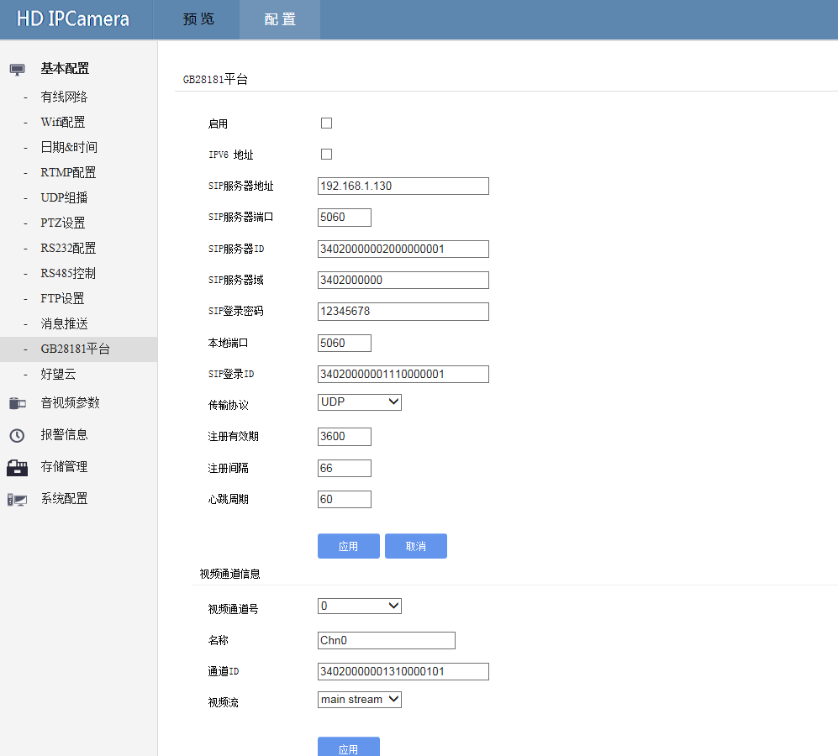

|  |  |  |
| --- | --- | --- |
| Parameter Name | How to understand | How to set |
| Enable | Enable or disable the GB28181 platform functions. | Select "Enable" and click "Apply" to take effect. This function is disabled by default |
| IPV6 Address | The IPV6 address was enabled or disabled. | Select "Enable" and click "Apply" to take effect. This function is disabled by default |
| Server Address | GB28181 Server address. | Enter a value in the input box and click "Apply" to take effect. The default value is "192.168.1.130". |
| SIP Server Port | SIP port of the device. | Enter in the input box and click "Apply" to take effect. The default is "5060". |
| SIP Server ID | ID of the device connected to GB28181. | Enter in the input box and click "Apply" to take effect. The default is "34020000001320000001". |
| SIP Server Name | GB28181 Server domain. | Enter in the input box and click "Apply" to take effect. The default is "3402000000". |
| SIP Login Password | GB28181 Password for external server registration. | Enter in the input box and click "Apply" to take effect. The default is "12345678" |
| Local Port | GB28181 Local port. | Enter in the input box and click "Apply" to take effect. The default is "5060". |
| SIP Login ID | ID of the push video data, which can be the same as the registration ID. | Enter in the input box and click "Apply" to take effect. The default is "34020000001110000001". |
| Transport Protocols | Four GB28181 transport protocols：UDP、TCP、TLS、DTLS。 | Select from the drop-down list and click "Apply" to take effect. By default, "UDP Protocol" is selected. |
| Valid period of registration（s） | GB28181 needs to refresh the registration when the registration validity period comes. | Enter in the input box and click Apply to take effect, default [3600] |
| Register Interval | Select the registration interval. | Enter in the input box and click Apply to take effect. The default is 66 [66]. |
| Heartbeat Cycle | Enter in the input box and click Apply to take effect. The default is 66 [66]. | Enter in the input box and click Apply to take effect. The default is 66 [66]. |
| Video Channel Number | Video channel is optional. | 在下拉列表中选择，点击应用后生效，默认选择通道【0】。 |
| Name | The device name is displayed on the OSD menu. | Enter in the input box and click Apply to take effect, default [Chn0] |
| Channel ID | You can enter a channel ID. | Enter in the input box and click Apply to take effect. The default is [34020000001310000101]. |
| Video Stream | Select the push code channel: primary/secondary code stream. | Select from the drop-down list and click Apply to make it take effect. By default, [main stream] is selected |

### 4.1.12 Cloud service

#### Operating Instructions

It is used to push video stream data to the target server. The device video data, configuration parameters, alarm information, video files and so on can be obtained through this protocol.

* Enable
*  Server URL
*  Device ID
*  Equipment verification code
*  Device name

#### Operation steps

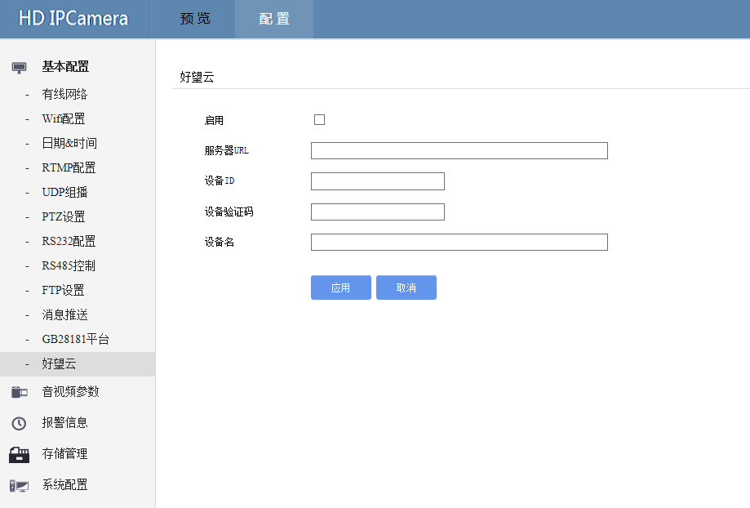

|  |  |  |
| --- | --- | --- |
| Parameter Name | How to understand | How to set |
| Enable | Open/Close cloud service function | Select "Enable" and click "Apply" to take effect. This function is disabled by default. |
| Server URL | Cloud service server address | Enter in the input box and click "Apply" to take effect. |
| Device ID | Device ID | Enter in the input box and click "Apply" to take effect. The default value is 5060 |
| Device Verification Code | Device access verification code | Enter in the input box and click "Apply" to take effect. |
| Device ID | Device Name | Enter in the input box and click "Apply" to take effect. |
|  |  |  |

## 4.2 Audio & Video Parameter

### 4.2.1 Video Coding

#### Operation Instruction

#### Set the encoding type, resolution, frame rate, I-frame interval, bit rate size and bit rate control of the first and second bit streams respectively.

#### Operation Steps

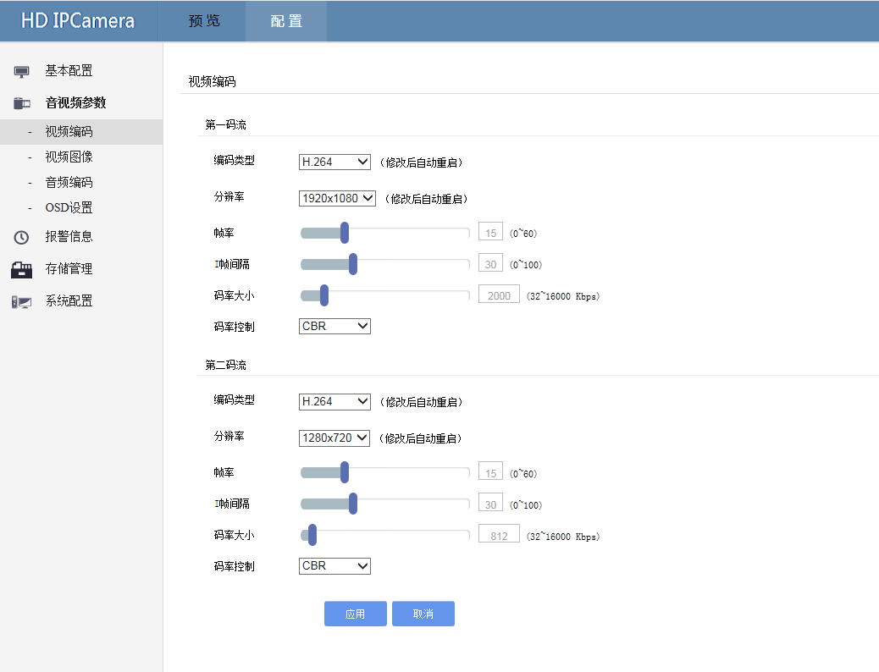

|  |  |  |
| --- | --- | --- |
| Parameter Name | How to understand | How to set |
| Video Coding | The type of video encoding determines the image quality of the transmitted video and the required network bandwidth. At present, high-definition network camera video coding standards mainly include:  H.264, H.265.   * H.264   H.264 includes H264 Base profile, H264 Main Profile and H264 High Profile, which are successively optimized and improved algorithms of H.264 compression algorithm. Their encoding compression performance is successively improved. When using pure hardware decoding devices, Compression algorithm The supported encoding compression algorithm should be selected according to the decoding performance of the hardware  .H.265  H.265 is a new video coding standard developed after H.264. H.265 standard revolves around the existing video coding standard H.264, retaining some of the original techniques, while improving some related techniques. The new technology uses advanced techniques to improve the relationship between streams, coding quality, latency, and algorithmic complexity to achieve optimal Settings.。 | Select from the drop-down list and click "Apply" to take effect. H.264 is selected by default. |
| Resolution | The resolution of the display device. Usually, the higher the resolution, the clearer the image.  Note: The resolution of the equipment varies according to different models | Select from the drop-down list and click "Apply" to take effect. The default value varies with different models |
| Frame Rate | Frame rate is a measure of the number of frames displayed. The higher the frame rate, the more realistic and fluid the picture will be. Due to the special structure of the human eye, if the frame rate is higher than 22.5f/s, the picture will be considered smooth and continuous. Frame rate at different frequencies:  50Hz：1f/s～25f/s；60Hz：1f/s～30f/s。  0-60 adjustable | Drag the scroll bar or enter in the input field, default [25] |
| I inter-frame space | The I-frame is called a key frame. It does not use any other frame as a reference, but only takes the information of this frame as a reference. The smaller the I-frame interval is, the higher the encoding performance is required, the better the video quality is, and the larger the bandwidth is occupied. | Drag the scroll bar or enter in the input field, default [30] |
| Code Rate Size | Displays the maximum video bit rate | Drag the scroll bar or enter in the input box, different models default [CBR] |
| Rate Control | Bit rate refers to the number of bits transmitted in a bit stream per second, that is, the number of data bits transmitted per unit time during data recording, transmission and storage. There are two types of bit rate:   * H.265(CBR )   The compression speed is fast, but the picture is not clear if the bit rate is not appropriate in the dynamic picture。   * H.265(VBR )   The bit rate can vary with the complexity of the image. Its coding efficiency is relatively high to ensure the clarity of the fast moving picture. | Select from the drop-down list and click "Apply" to take effect. By default, "CBR" is selected. |

### 4.2.2 Video Image

#### Operating Instruction

The parameters in image configuration are to obtain a balanced value for different scenes. Users can customize parameter Settings under the guidance of professionals according to the characteristics of the current scene. Parameter adjustment is not recommended if there is no special requirement.

* ISP channel choice
*  Image parameters
*  Ae parameters
*  The image control

#### Operation steps

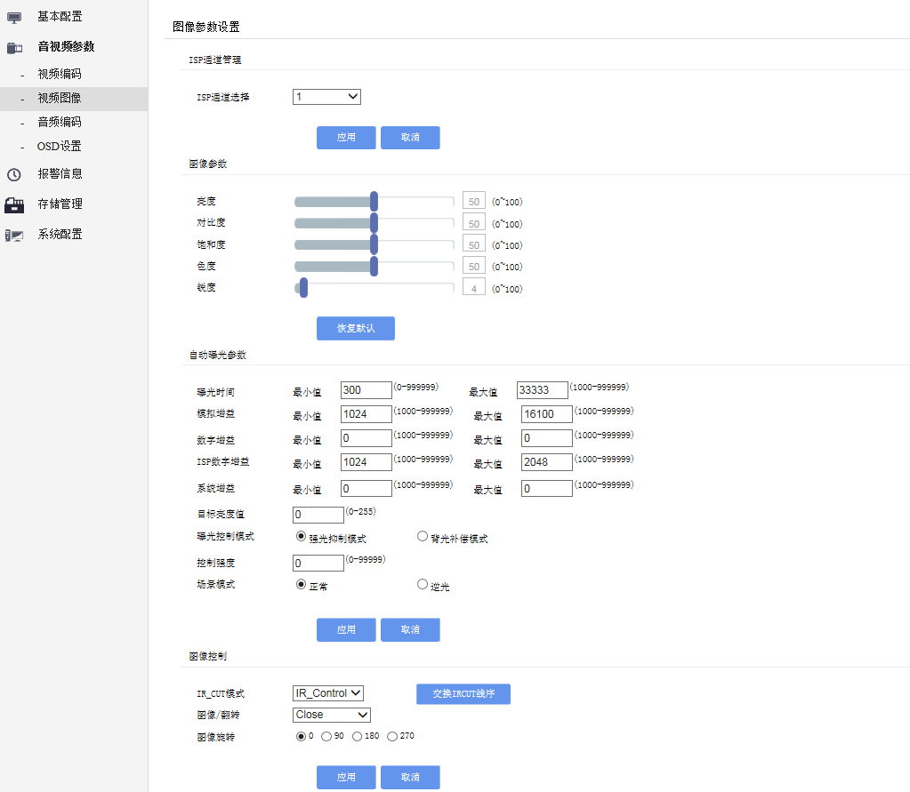

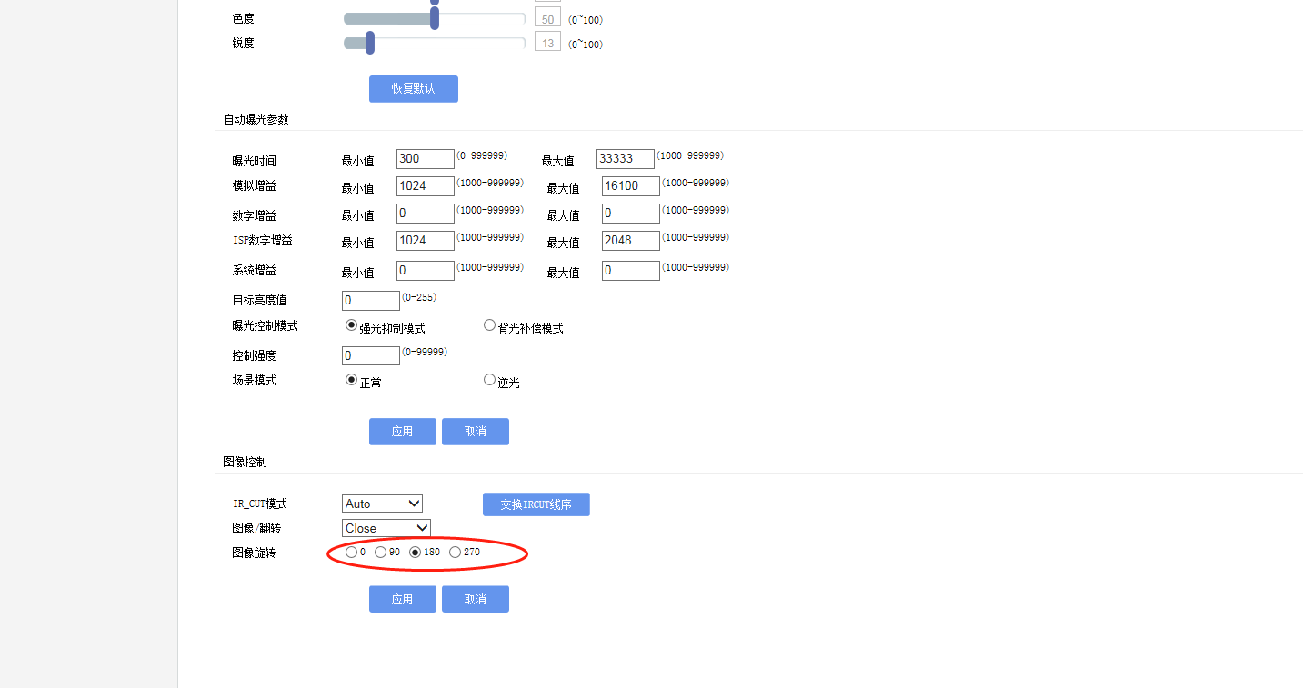

|  |  |  |
| --- | --- | --- |
| Parameter Name | How to understand | How to set |
| ISP Channel Choice | You can select channel 1 or channel 2 for parameter Settings. After the channel is selected, the parameter Settings on this page are for the channel | Select from the drop-down list and click Apply to take effect. By default, [Channel 1] is selected |
| Brightness | The brightness of the image as a whole. The brightness Settings range from 0 to 100. You can adjust them as required. The higher the value, the brighter the image; The smaller the number, the darker the image。 | Drag the slider to select, or enter a number in the input field, default [50]. |
| Contrast | Contrast is the measurement of different levels of brightness between the brightest and darkest areas of an image. Contrast Settings range from 1 to 100, which can be adjusted as required. The larger the value, the stronger the contrast; The smaller the number, the smaller the contrast | Drag the slider to select, or enter a number in the input field, default [50]. |
| Saturability | Saturation, also known as color purity, is the ratio of color to achromatic content (i.e., gray) in a color. This ratio determines the color's saturation and vividness. | Drag the slider to select, or enter a number in the input field, default [50]. |
| Chroma | Color is represented by both luminance and chroma, which is the property of a color that does not include luminance and reflects the hue and saturation of the color. | Drag the slider to select, or enter a number in the input field, default [50]. |
| Acutance | Sharpness refers to the sharpness of the image plane and the sharpness of the edge. The higher the sharpness, the higher the contrast, the sharper the edges. The sharpness setting value ranges from 0 to 100. Users can adjust it as required. | Drag the slider to select, or enter a number in the input field, default [50].。 |
| Recovery default | Restore image parameters (brightness, contrast, saturation, chroma, sharpness) to factory Settings. | Click to take effect |
| Exposure Time | The minimum exposure time (0-99999) and maximum exposure time (1000-99999) can be set. | Enter a number in the input box, default [300]. |
| Exposure Gain | The exposure gain can be even minimal (0-99999) and maximum (1000-99999).。 | Enter a number in the input box, default [1024]. |
| Digital Gain | Minimum (1000-99999) and maximum digital gain can be set  (1000-99999)。 | Enter a number in the input box, default [0]. |
| ISP Digital Gain | You can set the minimum (1000-99999) and maximum ISP digital gain(1000-99999)。 | Enter a number in the input box, default [1024]. |
| System Gain | You can set the minimum (1000-99999) and maximum system gain  (1000-99999)。 | Enter a number in the input box, default [0] |
| Target brightness value | The exposure target brightness value of the device can be set (0-255). | Enter a number in the input box, default [0] |
| Exposure mode control | When the device is directly exposed to strong light, select the strong light suppression mode or backlight compensation mode  **Strong inhibition:**  In the image, the video information in the strong light part is processed by DSP, and the signal brightness of the video is adjusted to the normal range to avoid the big contrast between the front and back in the same image. Strong light suppression technology can effectively suppress the halo caused by direct exposure to strong light, fuzzy video image, can automatically distinguish strong light point, and compensate the area near strong light point to obtain clearer image. The webcam with the strong light suppression filter processing chip can effectively suppress the strong light of the face  **Backlight compensation:**  It can effectively compensate the dark defect of the main body of the picture when the camera shoots in the backlight environment. When the backlight compensation function is introduced, the camera only detects a subregion of the whole field of view, and determines the operating point of the AGC circuit by calculating the average signal level of this region. Because the average level of the subregion is very low, the AGC amplifier will have a higher gain, which increases the amplitude of the output video signal, thus making the main picture on the monitor clear. The background is a little brighter, but it's not the same  The subjective brightness difference of the main picture will be greatly reduced, and the visibility of the whole field of view will be improved | Click "Apply" and it will take effect. The default is "Strong light suppression mode". |
| Control Strength | Set the strong light control value of the device (0-99999) | Enter a number in the input box, default [0]. |
| Scene Mode | Select the device mode based on the application scenario: Normal or reverse light | Enter a number in the input box, default [Normal]. |
| IR_CUT Mode | Choose IR_CUT and switch mode：  **Automatic mode:**  The device automatically switches the day/night mode by judging the ambient light. When the threshold of day/night switchover is reached, the device automatically switches the day/night mode  IR_Control mode:  The infrared photoresistor determines the ambient light, reaches the threshold set in the device, and switches the day/night mode.   * Color：   The device is fixed in color mode (daytime mode) and displays color images regardless of the external environment, day or night   * W/B：   The device is fixed in white mode (night mode), showing black and white images regardless of the external environment, day or night | Select from the drop-down list and click "Apply" to take effect. The default mode is "IR_Control". |
| Image/flip | The video picture is rotated horizontally, flipped vertically, and flipped horizontally and vertically simultaneously | Select from the drop-down list and click "Apply" to take effect. By default, "Close" is selected. |
| [Image rotation](javascript:;) | Select Set image rotation Angle：0°、90°、180°、270° | Click "Apply" to take effect. The default value is "0" (no rotation). |

### 4.2.3 Audio coding

#### Operation instruction

With audio configuration, you can enable the audio, select the sampling rate, and select the encoding type to improve the audio effect. Some products support dual-channel configuration.

* Open voice
* A track number
* Encoding type
* Sampling rate
* Sound size

#### Operation steps

#### 

|  |  |  |
| --- | --- | --- |
| Parameter Name | How to understand | How to set |
| Open voice | Enable the audio input function. If the device interface has an audio input peripheral (microphone or pickup), and enable this function, you can collect audio data. If no audio input peripheral is available or the function is disabled, audio data cannot be collected | Check "Open Audio" and click "Apply" to take effect. |
| Channel quantity | For products that support dual channel input, you can select channel 1 and Channel 2 respectively. | Select from the drop-down list and click Apply to take effect. The default option is [1]. |
| Coding Type | Different encoding formats are mainly reflected in the processing methods of frequency, quantization digit and other data.  **W/B:**  Mainly applied to Internet products, the most common type.  **G711_ALAW:**  Mainly used in Europe and other parts of the world.  **G711_ULAW:**  Mainly used in North America and Japan. | Select from the drop-down list and click "Apply" to take effect. By default, "G711A" is selected. |
| Sampling Rate | The number of times a device samples a sound signal in a second. The higher the sampling frequency, the more real and natural the sound is restored. It is graded from 0 to 100. | Enter a number in the input box. Default is 80.  。 |

### 4.2.4 OSD set

#### Operation Instruction

#### The audio encoding types include AAC, G711_ALAW, and G711_ULAW.

#### Using OSD parameters, you can define whether to display watermark, display location, and display mode.

#### ISP channel choice

#### Open the show time

#### Open time automatic back color

#### Time color values

#### Time display X coordinate values

#### Time display Y coordinate values

#### Time display font size

#### Open text display

#### Automatic text color

#### Text color values

#### Text display X coordinate values

#### Text display Y coordinate values

#### Text content

#### Text font sizeOperation steps

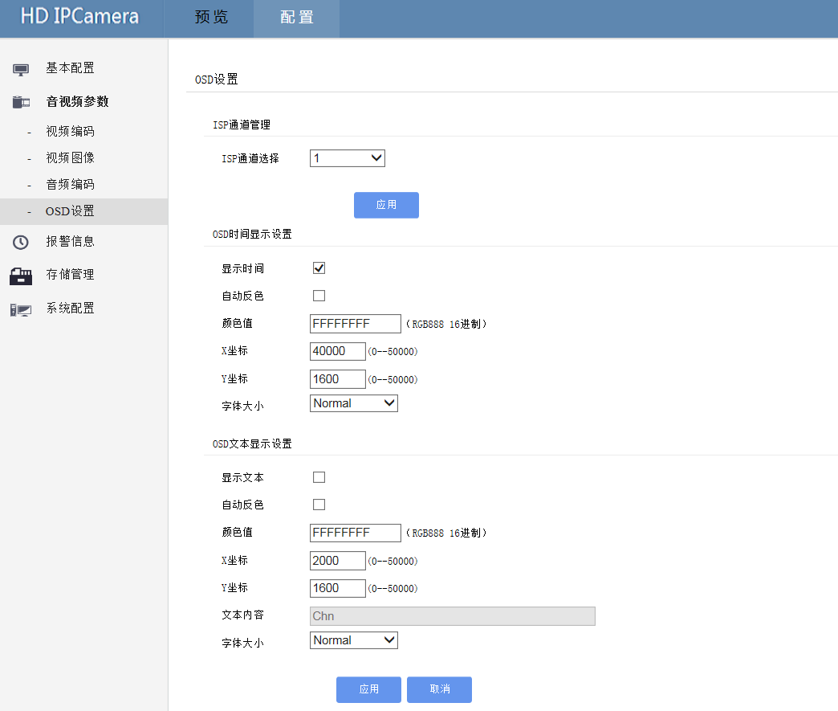

|  |  |  |
| --- | --- | --- |
| Parameter Name | How to understand | How to set |
| ISP Channel Selection | You can select 1-5 channels to set the OSD menu | Select from the drop-down list and click "Apply" to take effect. By default, "Channel 1" is selected. |
| Display Time | You can set the time to hide and display in the screen | This parameter takes effect after being selected. It is selected by default |
| Time Automatic Inverse | You can set whether the time in the real-time picture will automatically reverse color according to the display position of the time in this picture. If the time is white and the picture is white here, the time will not be obvious and will become obvious after the reverse color | This parameter takes effect after being selected. It is selected by default |
| Time color value | Set the color value of the time in the real-time picture. The color value is divided by hexadecimal level according to the RGB color standard | Enter the color value in the input box, default [FFFFFFFF] |
| Time display X coordinate | Set the time to display the horizontal coordinates of the position in the real-time screen, 0-5000 coordinate values | Enter the X coordinate value in the input box, default [40000] |
| Time display Y coordinate | Set the time to display the vertical coordinates of the position in the real-time screen, 0-5000 coordinate values. | Enter the Y coordinate value in the input box. The default is [1600]. |
| Time display font size | Set the font size displayed by time in the real-time screen, which can be divided into Small, Normal, Big1, and Big2. | Select from the drop-down list and click Apply to take effect. By default, [Normal] is selected.。 |
| Display text | You can set the time to hide and display in the screen. | This parameter takes effect after being selected. By default, this parameter is not selected. |
| Text automatically inverts color | You can set whether the text in the real-time picture will automatically reverse color according to the display position of the time in this picture. If the time is white and the picture is white here, the time will not be obvious and will become obvious after the reverse color. | This parameter takes effect after being selected. By default, this parameter is not selected. |
| Text color value | Set the color value of the text in the real-time screen. This color value is divided by hexadecimal level according to the RGB color standard. | Enter a color value in the input box, default [FFFFFFFF]. |
| The text displays the X coordinate | Set the horizontal coordinates of the display position of the text in the real-time screen, 0-5000 coordinate values. | Enter the X coordinate value in the input box, default [20000]. |
| The text displays the Y coordinate | Set the vertical coordinates of the position of the text displayed in the real-time screen, 0-5000 coordinate values. | Enter the Y coordinate value in the input box. The default is [1600]. |
| Test Contents | Enter the text content to be displayed in the live screen. | Enter text in the input box, default [Chn]. |
| Text displays font size | Set the font size of the text displayed in the real-time screen, which can be divided into Small, Normal, Big1 and Big2. | Select it from the drop-down list and click Apply. By default, [Normal] is selected. |

### 4.3 Alarm set

#### Operation instruction

* Enable motion detection
* Enable input alarm
* IO alarm output GPIO choice
* Alarm and capture image
* Alarm recording

#### Operation steps

#### 

|  |  |  |
| --- | --- | --- |
| Parameter | How to understand | How to set |
| Start motion detection | Motion detection detects the motion state of the video by detecting the brightness change of the video, and obtains the video detection and analysis results. When a moving object passes by the camera, the motion is triggered and the set linkage action can be linked. | This parameter takes effect after being selected. By default, this parameter is not selected. |
| Sensitivity | Mobile in the sensitivity of detection algorithm of moving object recognition, the higher the sensitivity, the easier it is to recognize objects move, the points (60/70/40/50 / / 80/90/1000 level, the higher the grade, the more sensitive. | Select from the drop-down list and click "Apply" to take effect. By default, "10" is selected. |
| Start input IO alarm | The device detects the external trigger signal to determine whether it is triggered and then performs corresponding actions. | Select or click Apply to take effect. This option is not selected by default |
| Input Level | The device detects the active level of the external input, that is, the device detects whether the external input is High level or effective LOW level to make corresponding actions, which can be divided into LOW(low level) and High(high level). | Select from the drop-down list and click "Apply" to take effect. By default, "LOW" is selected. |
| IO Alarm Output | Through the internal software control I/O port high and low level (circuit on and off), users can control the peripheral circuit on and off on this basis; You can trigger alarm I/O to linkage actions set in linkage actions such as capture picture and video recording, and then select Close(close output), select output IO1, and select output IO2. | Select from the drop-down list and click "Apply" to take effect. By default, "Close" is selected. |
| Alarm capture | Select the number of images captured by the device after triggering the alarm, which can be divided into Close(no capture)/1 /2 /3 /4 /5 /6 /7 /8 /9 /10 | Select from the drop-down list and click "Apply" to take effect. By default, "1" is selected. |
| Alarm video code stream | Select the code stream that triggers alarm video: 0(primary code stream), 1(secondary code stream) |  |
| Alarm pre-recording time | Select the bitstream that triggers alarm video: 0(primary bitstream), 1(secondary bitstream). | Select from the drop-down list and click Apply. The default option is "Close". |
| Alarm video duration | Select the length of a video after triggering the alarm video, which is Close(no recording)/10 seconds /20 seconds /60 seconds /120 seconds /200 seconds /300 seconds. | Select from the drop-down list and click Apply. The default option is "Close". |

### 4.4 Storage Management

### 4.4.1 Storage device

Manage local TF card storage and USB flash drive storage, including viewing total capacity, used capacity and formatting operations.

* Capacity
* State
* Formatting

#### Operation steps

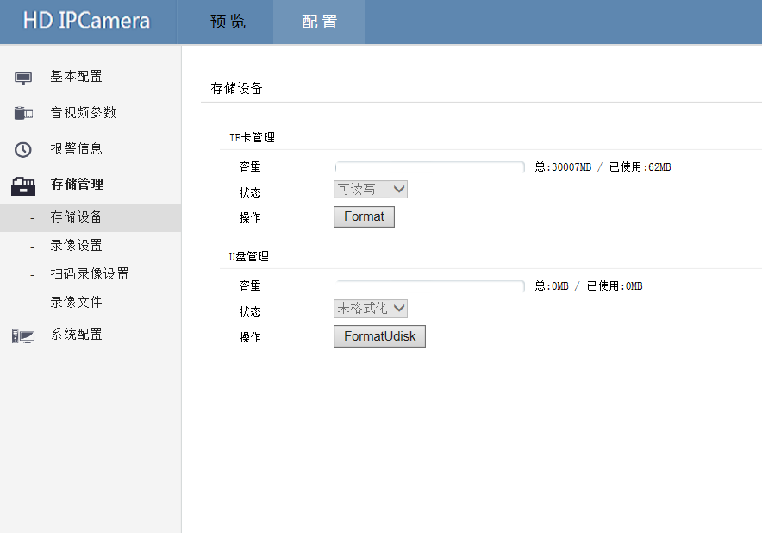

|  |  |  |
| --- | --- | --- |
| Parameter Name | How to understand | How to set |
| Total Capacity | TF card internal storage. | Read only，0-256GB。 |
| Space Available | TF card available space | Read only. |
| Formatting | Format TF card | - |

### 4.4.2 Video set

#### Operation Instruction

Open/close video, select video code stream, select video file size,

*  Video state
*  Video stream
*  Video file size
*  Video equipment selection
*  Video strategy

#### Operation Instruction

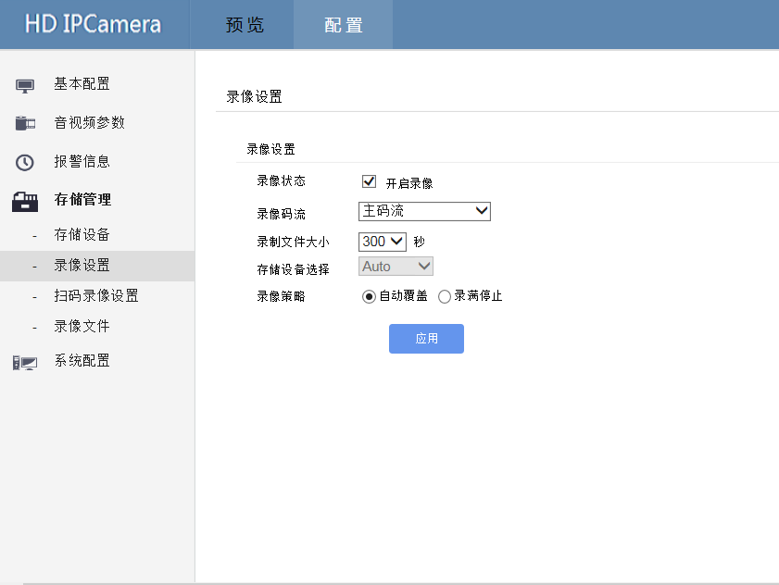

|  |  |  |
| --- | --- | --- |
| Parameter Name | How to understand | How to set |
| Recording State | Enable/disable video recording | This parameter is selected to take effect. It is selected by default. |
| Recording Stream | Select the bitstream of the device that you want to record: primary or secondary. | Select from the drop-down list and click "Apply" to take effect. By default, "main Stream" is selected.。 |
| Recording File Size | Select the size of the video file (recording duration), minutes 10 seconds /30 seconds /60 seconds /120 seconds /1800 seconds /240 seconds /300 seconds /600 seconds. | Select from the drop-down list and click "Apply" to take effect. By default, "300 seconds" is selected. |
| Recording Device Choice | Device selection for appearance | Fixed Auto(Automatic) |
| Recording Strategy | Select the strategy of video recording, and deal with TF memory card and U disk after full recording: Automatic covering:  When the TF card or USB disk is full, it will automatically overwrite the earlier files and keep the Latest files.  Its full so far:  When the TF card or U disk is full, it will automatically stop recording | Select or click "Apply" to take effect. By default, "Auto Overwrite" is selected. |

4.4.3 Scanning video Settings (customized application)

Operation instruction

Serial scanning is used to control video recording, and video recording is performed after code scanning.

* Open the serial port
*  Serial number
*  Baud rate
*  Device type
* The biggest video time

**Operation steps**

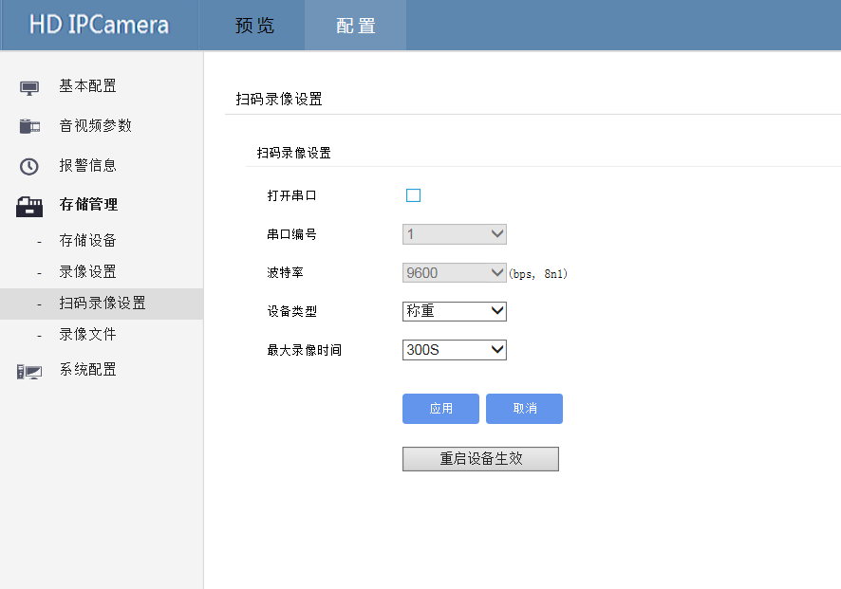

|  |  |  |
| --- | --- | --- |
| Parameter Name | How to understand | How to set |
| Open serial port | Enable/disable the serial port | Check and click Apply to take effect. By default, "Close serial port" is selected. |
| Serial port number | Serial port number for scanning | Fixed【1】 |
| Baud Rate | Serial port number for scanning | Fixed【9600】 |
| Device Type | Select the type of scanning equipment, including bath, weighing, stroking and observation table | Select from the drop-down list, click Apply and it will take effect. The default option is "weigh". |
| Maximum Recording Time | Select the size of the video file (recording duration), minutes 10 seconds /30 seconds /60 seconds /120 seconds /1800 seconds /240 seconds /300 seconds /400 seconds /500 seconds /600 seconds. | Select from the drop-down list and click Apply to take effect. The default option is [300S]. |

### Note: This kind of function can only take effect after the device is restarted. Please click "Restart the device to take effect" after the setting is completed.

### 4.4.4 Recording File

#### Operation Instruction

You can query, view, and play back captured pictures and video files on the real-time web page.

* Choose time
* File type

**Operation steps**

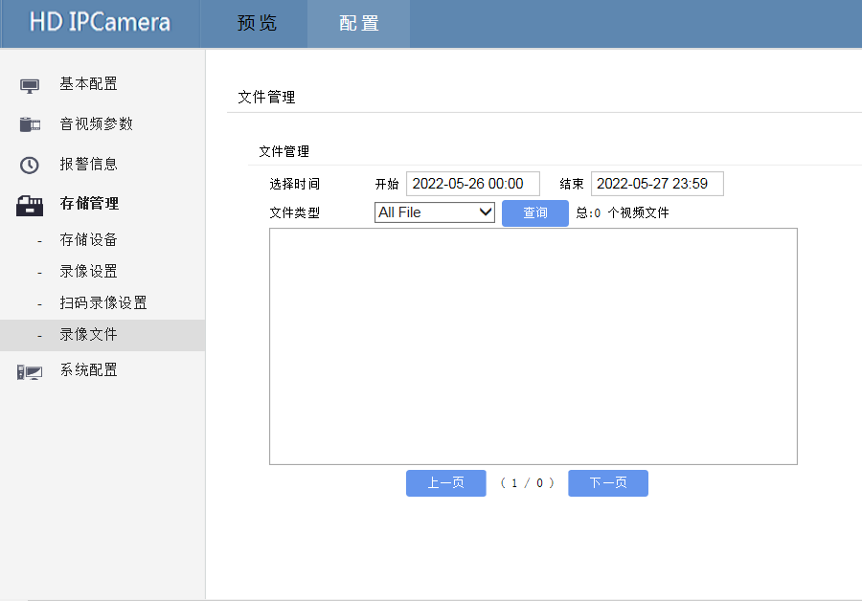

|  |  |  |
| --- | --- | --- |
| Parameter Name | How to understand | How to set |
| Select Time | Select the start time and end time of the query period. | Click the pop-up time selection and select the corresponding time in the small window. |
| Type File | Select the type of File to be queried, All File /Normal Record /Alarm Record /Snap Jpg | Select from the drop-down list and click "Query". The default is "All File". |

### 4.5 System set

### 4.5.1 User Management

#### Operation Instruction

You can add, modify, or delete a user, and select permissions for the user in the User Group interface.

*  Modify user
*  Delete user
*  Add user

#### Operation steps

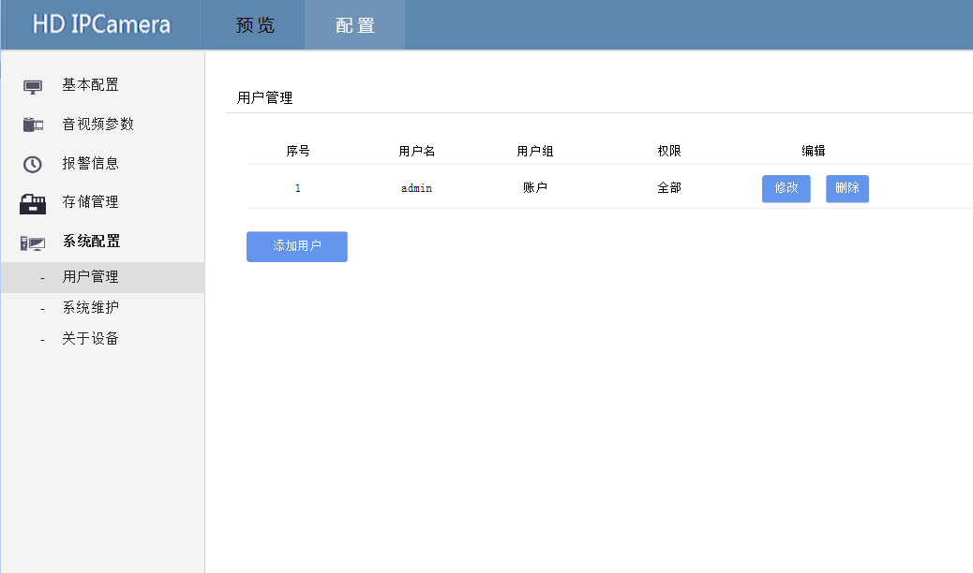

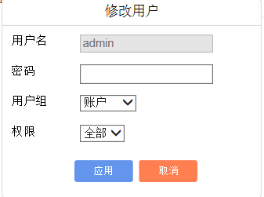 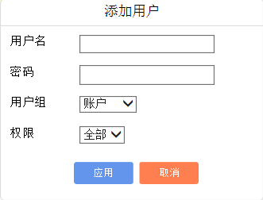

### 4.5.2 System Maintenance

### Operation Instruction

Display the system running time, restart the device, restore factory Settings, click to take effect.

* System running time
* Restart equipment
* Restore factory Settings
* Device restart includes but is not limited to the following situations:
* Equipment parameter configuration error, can't work normally.
* Users need to reconfigure the device parameters, and make the parameters take effect.
* Remote contr
* 【 Restart 】 Soft restart the device with constant power.

**Operation steps**

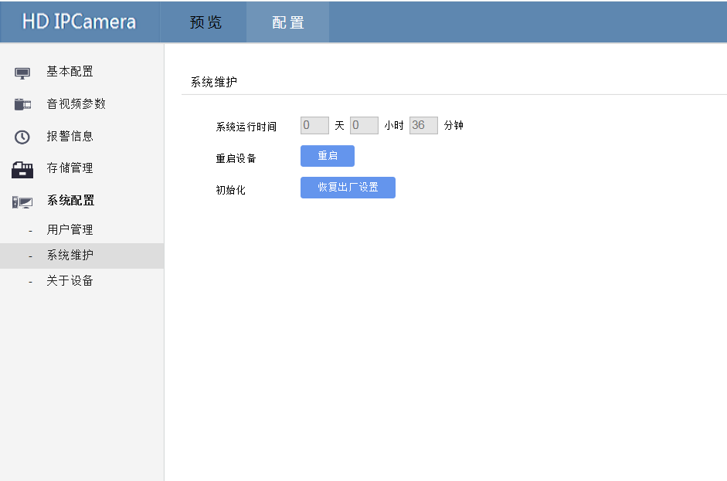

### 4.5.3 About device

#### Operation Instruction

On the device information page, you can view the device model, software version, Web OCX control version, and updated logo file.

**Operation steps**

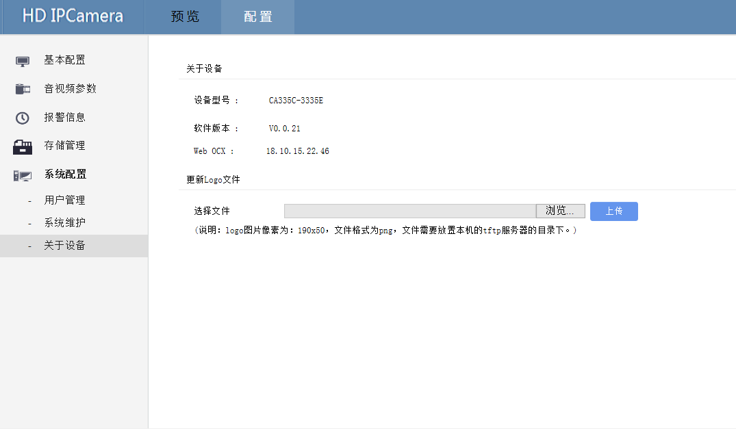

If you need to update the logo, click Browse, open the local folder, and select the logo image to update. Click Upload to take effect.

Note: The pixel of the logo image is 190x50 and the format is png.

1. FAQ

5.1 Failure to Access the Web interface of the Device

IP address is not in the same network segment: Use our search tool DeviceTool to search for the device (because the network firewall is enabled on some computers, DeviceTool cannot search for the device IP address). If the device IP address is found but the connection fails, check whether the device IP address and the computer are on the same network segment, or check whether the device has hardware or serious software problems. The search fails.

network environment uncertainty: PC using CMD command in the command line window, use the ping command to check the network, to see if online equipment.

● IP address footprint: the equipment of the cable connected to the PC so, check whether the normal work, if the IP address being used because it is over, you can reset the device IP address.

● the browser cache data is not deleted:

The steps are as follows (using Internet Explorer11 as an example) :

1. Open a browser.

2. Choose Tools > Internet Options > General.

3. Click Delete. The Delete Browsing History dialog box is displayed.

4. Check all the check boxes.

5. Click Delete. Log in to the device web page again.

● bar display abnormal

If Internet Explorer 7 or a later version is used on some computers, no font is displayed in the function area of the sidebar. You are advised to use Internet Explorer 11 to perform web page operations on devices. Use Internet Explorer to press F12 to go to Developer Tools and switch to Internet Explorer 11 compatibility mode

### 5.2 Control installation abnormally.

Attention

When the control is installed, a message like the following appears, indicating that part of the runtime library is missing in the computer. You can contact the relevant supplier to provide the runtime library or download it from the Internet.

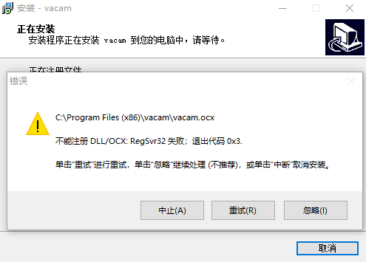

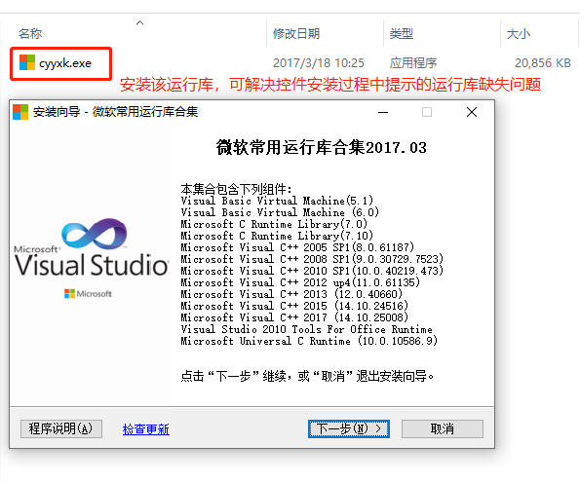

## Abbreviation

**C**

CBR Continuous Bit Rate

**D**

DHCP Dynamic Host Configuration Protocol

DNS Domain Name Server

DDNS Dynamic Domain Name Server

**F**

FTP File Transfer Protocol

**G**

GAMA Graphics Assisted Management Application

**H**

HTTP Hypertext Transfer Protocol

HTTPS Hypertext Transfer Protocol Secure

**I**

ISO International Standard Organized

IP Internet Protocol

ID Identity

IPC Internet Protocol Camera

**M**

MJPEG Motion Joint Photographic Experts Group

MAC Media Access Control

**N**

NAS Network Attached Storage

NTP Network Time Protocol

NTSC National Television System Committee system

NVR Network Video Recorder

**O**

OSD On Screen display

**P**

PoE Power over Ethernet

PPPoE Point-to-Point Protocol over Ethernet

PTZ Pan Tilt Zoom

**S**

SMTP Simple Mail Transfer Protocol

SNMP Simple Network Management Protocol

**U**

UPnP Universal Plug and Play

**V**

VBR Variable Bit Rate

VMS Video Management System